Bingo Card Assignment

Objective:
Using the table tools and understanding table formatting.

Directions:
Create 6 different BINGO cards they usually are 5 by 5 with the word BINGO on the top each letter stands for a column. You will use formatting tools to make them look believable and different. Changing color, style, and patterns will help to create different looks in the cards.

B | = | 1-15
I | = | 16-30
N | = | 31-45
G | = | 46-60
O | = | 61-75

- Make sure to include the free space in the center of the card.
- Make your cards fill up the page as best you can, if you want to keep them a square or smaller rectangle that is fine just use as much of the paper as you design allows.

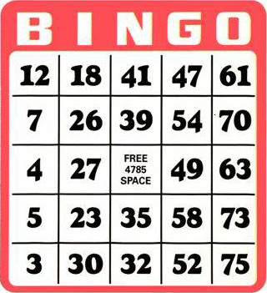

Saving:
Save as “Bingo Cards”

