Step 1- Open Microsoft Excel

Step 2- Enter the Worksheet Title

- Click cell (an intersection of a row & column) A1
(cell A1 becomes the active cell, surrounded by a highlight)
“A1” is the cell reference, or name of the cell.

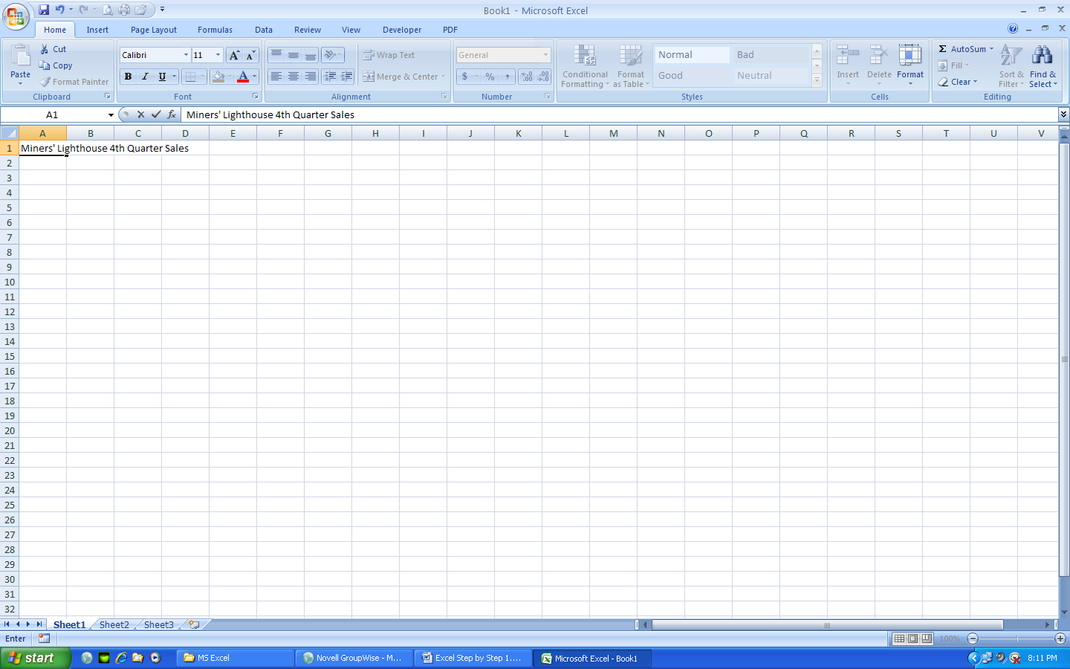
- Type Miners’ Lighthouse 4th Quarter Sales in cell A1 (the title displays in cell A1 and the formula bar, the insertion point is a blinking vertical line that indicates where the next character will display)

- Point to the Enter box, click it and the entry is complete. Note that as the Enter box is clicked, both it and the Cancel Box disappears.
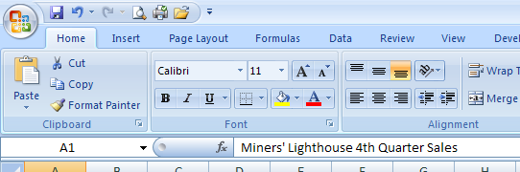

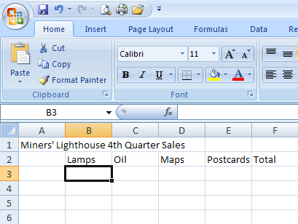

Step 2- Enter titles for Columns (run vertical, labeled with letters)

- Click cell B2.

- Type Lamps in cell B2.

- Press the RIGHT ARROW key. (C2 becomes the active cell)

- Repeat steps B and C for the other column titles in Row 2. Type Oil in C2, Maps in D2, Postcards in E2, and Total in F2. Complete the entry in F2 by pressing Enter.

Step 3- Enter titles for Rows (run horizontal, labeled with numbers)

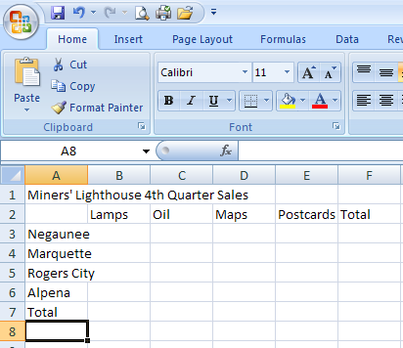
- Click cell A3. Type Negaunee and press the DOWN ARROW or ENTER key

- Repeat step A for the remaining row titles in Column A. Type Marquette in A4, Rogers City in A5, Alpena in A6, and Total in cell A7.

- In Excel, text is automatically left aligned unless you change it. Text is considered any combination of numbers, spaces, and nonnumeric characters:

5589CHI 678 920-956 CET678

Step 4- Entering Numeric Data

- You can enter numbers to represent amounts and can contain only the following characters: 0 1 2 3 4 5 6 7 8 9 + - ( ) / $ % E e

Table 1.1 Sales Figures

Miners’ Lighthouse 4th Quarter Sales
Store Location | Lamps | Oil | Maps | Postcards
Negaunee | 552.09 | 689.02 | 302.54 | 214.98
Marquette | 975.34 | 1012.11 | 214.27 | 222.88
Rogers City | 1199.20 | 566.43 | 908.76 | 52.87
Alpena | 345.67 | 124.86 | 78.12 | 300.89
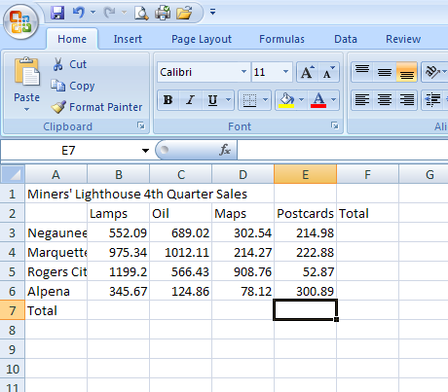
- Click cell B3. Type 552.09 and then press the RIGHT ARROW key. Enter 689.02 in cell C3, 302.54 in D3, and 214.98 in cell E3. Now all of the information is entered for the Negaunee store. The numbers in row 3 are right aligned unlike text that is left aligned.

- Click cell B4. Enter the remaining numbers from the Sales Figures table above for the next three store locations.

Step 5- Sum a Column of Numbers
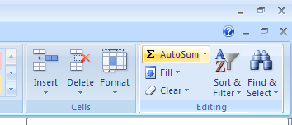
- Click cell B7 and then point to the AutoSum button on the Editing group of the Home Tab Ribbon.

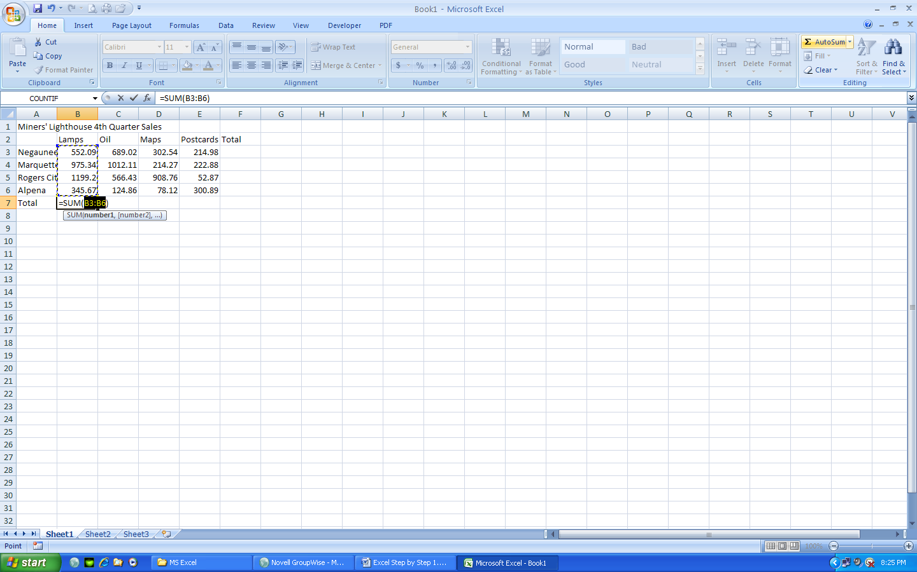
- Click the AutoSum button, Excel responds by displaying = SUM (B3:B6) in the formula bar and in the active cell. A formula is an equation set up to compute an answer, act similar to a calculator.

- Click the AutoSum button again or hit the Enter key. Excel will enter the sum of the range in cell B7.

- A range is a series of two or more cells in a column or row. You can enter a range by typing the beginning cell reference, a colon (:), and the ending cell reference. (Example B3:B6)

Step 6- Copy a cell to adjacent cells in a row

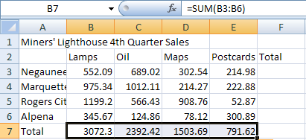
- With cell B7 active, point to the fill handle, the lower right corner of the cell (the pointer changes from a white plus sign to a black plus sign).

- Drag the fill handle to select the paste area, range C7:E7.
- Release the mouse button and Excel copies the formula.
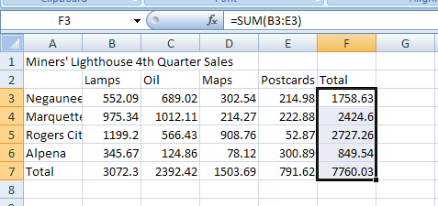

Step 7- Determine the row totals at the same time

- Click cell F3 and with the mouse pointer in cell F3 and in the shape of a block, white plus sign, drag the mouse pointer down to cell F7.

- Click the AutoSum button.

- Click cell A8 to deselect the range F3:F7.

Formatting the Worksheet

Formatting means to emphasize different parts of the worksheet. It allows readers to follow the data more easily. Many aspects can be formatted including:

- Font type- defines the letters shape and appearance
- Font size- specifies the character height, width. A point size is 1/72 of one inch in height. So, a 10-point character is 10/72 of an inch in height.
- Font style- regular, bold, italic, underlined

Step 8- Bold a Cell

- Click Cell A1 and the Bold button in the Font group of the Home Tab Ribbon

Step 9- Increase the Font Size

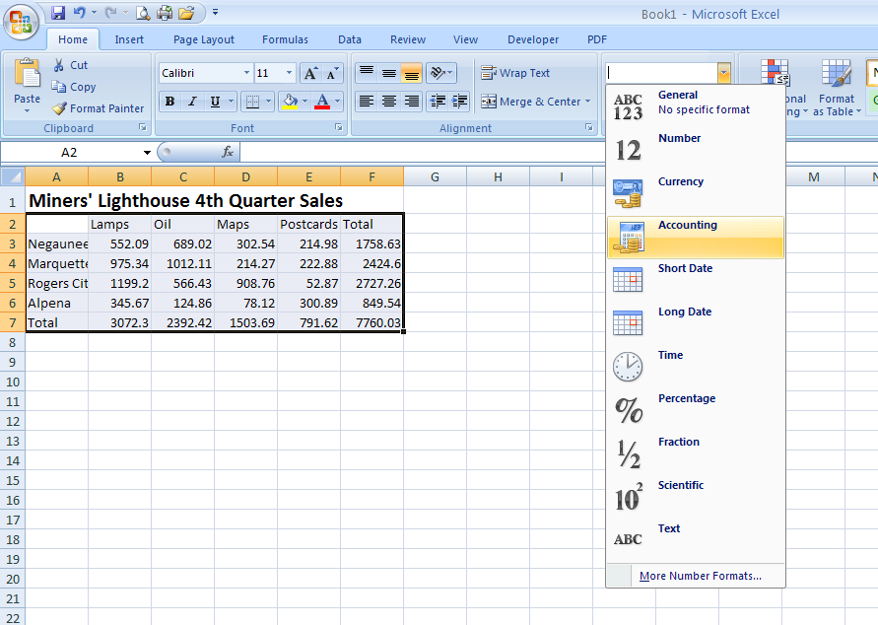
- With Cell A1 highlighted, change the font size to 16.

Step 10- Use AutoFormat to format the body of the worksheet

- Select cell A2 and drag the mouse to F7 to select the range of cells.

- In the Number group of the Home Tab Ribbon, drop the menu down and select Accounting.

- Excel automatically formats the range A2:F7

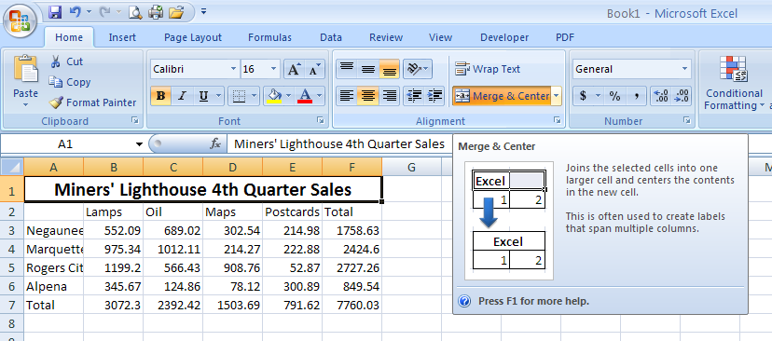
Step 11- Center the Title Across Columns

- Click cell A1. Drag the white block plus sign to cell F1 (the rightmost cell).

- Click the Merge and Center button on the formatting toolbar.

- Excel merges the range A1:F1 and centers the title.

- Format cells and columns to best fit. Best fit widens the column or lengthens the row to fit the longest piece of data so it displays correctly. If you ever receive an error that looks like this in a cell “######”
It means there is data in the cell, but not enough room to display the data.

To “best fit” your column or row, put the insertion point on the line that separates Column A and Column B (the pointer will turn from a white plus sign to a crosshair) then double click. Do the same for the rest of columns and rows in the spreadsheet.

Step 12- Adding a Chart to a Worksheet

Embedded chart- a chart that is added to an active worksheet

- Select the range A2:E6.

- With the range selected, make the Insert Tab ribbon active and in the Charts Group, drop the menu down under Column and select 3-D Column Chart.

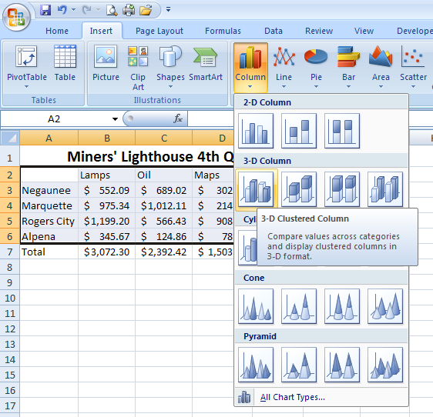

- Point to an open area in the lower right section of the chart so that “Chart Area” displays. Drag the chart down and to the left to position the chart over the upper-left corner of cell A9.

- Point to the middle-sizing handle on the right edge of the selection rectangle. While holding down the ALT key drag to the right edge of column G.

- Do the same thing using the lower middle sizing handle and dragging up to Row 19. Deselect the chart.
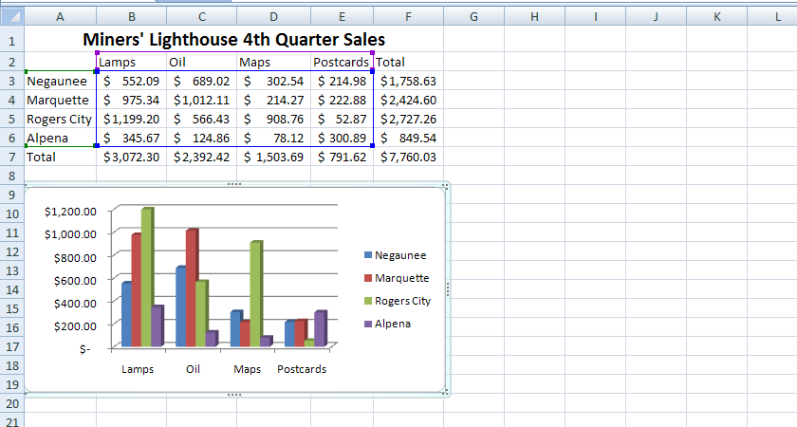

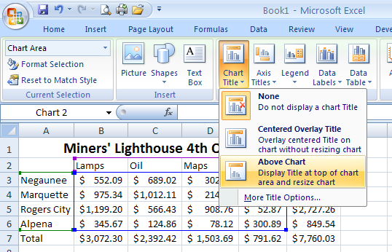

Step 13- Adding a Title and Axis Labels to the Chart

- With the chart selected, note that the green tab “Chart Tools” appears on the ribbon. This tab is specific to formatting charts. To add a title and axis labels, click on the Layout Tab. In the Labels section drop down the menu for Chart Title and choose “Above Chart”. When the placeholder appears, type the title “Miners’ Lighthouse 4th Quarter Sales.”

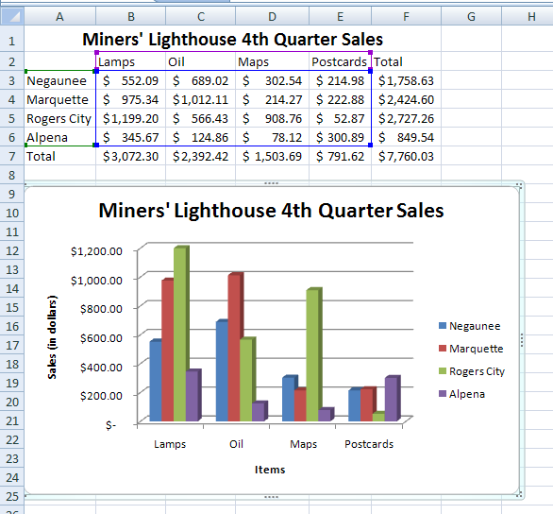
- Do the same under Axis Titles. Label the Primary Horizontal Axis “Items Sold” and label the Primary Vertical Axis “Sales (in dollars)”

Step 14- Saving a Workbook

- Go to the Microsoft Office Button
- Click Save As
- If an older version click Save As 1997-2003
- Select your folder
- Save the document as Miners’ Lighthouse Sales
- Click Save

Step 15- Printing a Workbook

- Many ways are available to print the workbook. Choose 1 of the following:
Print icon
CTRL + P
Microsoft Office Button→Print

