WORD PROCESSING ACTIVITY 2
Jedi Knights must have good computer skills!
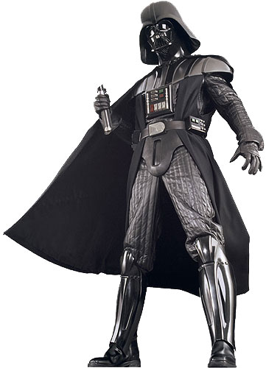
What you will practice:
- Creating a centered list
- Using the horizontal centering command
- Using bold, italic, and underline features
- Changing font and font size

DIRECTIONS:
- Open a new Word document. Change to Arial, Size 12, and type your name. Hit ENTER one time.
- Type Activity 2. Hit ENTER two times.
- Change the alignment to CENTER. (Alignment icons at the top of the screen in the menu bars. ) READ THROUGH THE DIRECTIONS BEFORE CONTINUING!
- In a list form, type the words on the left side where it says “What to Type”. Use Upper and Lower case letters as shown in the sample. Press the ENTER key at the end of each line (twice when a blank line is indicated.) DO NOT TYPE THE WORDS “BLANK LINE”!!!
- Change the font sizes and special formats as shown in the right column. Check the sample on the back side frequently.
- Save as Activity 2.

WHAT TO TYPE: HOW TO TYPE IT

EXERCISES Size 24 point, bold, all caps.
Blank line
Monday Size 20, underline
Blank line
Chest Size 16, italic and bold
Blank line
Bench Press Size 14
Push-ups Size 14
Flies Size 14
Blank line
Abdomen Size 16, italic and bold
Blank line
Negative sit-up Size 14
Crunch Size 14
Hip lift Size 14
Blank line
Wednesday Size 20, underline
Blank line
Back Size 16, italic and bold
Blank line
Lateral raise Size 14
Rowing Size 14

