WORD PROCESSING

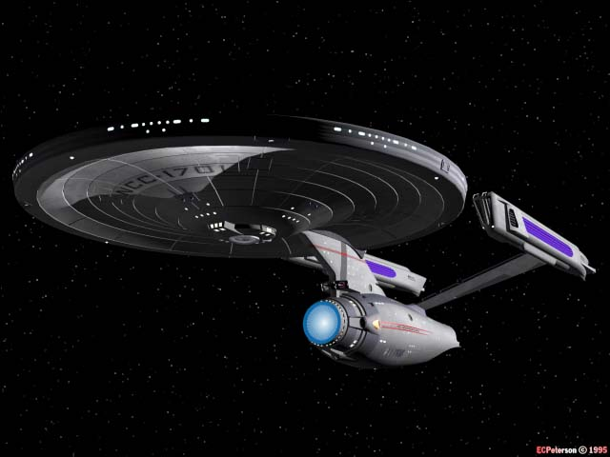

ACTIVITY 4

Review of Essential Skills

* Font Style, Size
* Line Spacing
* Margins
* TAB key
* Clip Art
* Bullets and Numbering
* Spell Check
* Alignment: Center & Right
* Word Wrap
* Font: Bold, Italics, Underline
* Copy & Paste, Drag & Drop

1. Open a Word document. Change the margins to 2 inches (5.08 cm) on each side. Change the font style to Arial, size 16 point.

2. Type your name. Hit ENTER. Type Activity 4. Hit ENTER twice.

3. Type the following paragraphs. Use word wrap. Type the list of characters under the second paragraph. Use TAB to indent the first sentence of each paragraph.

Han Solo

Quick thinking and skilled with a blaster, Han Solo is a smuggler, space pirate, and captain of the Millennium Falcon. When he and his Wookee first mate, Chewbacca**,** are hired to transport Luke Skywalker and Obi-Wan Kenobi, Han becomes involved in the rescue of Princess Leia.

Han falls in love with Leia and is drawn to her cause. He finds a focus for his flyboy talents. No longer a reckless adventurer, Han becomes one of the Rebellion’s most courageous heroes.

4. Hit Enter twice. Type these characters in list form: Master Yoda, Han Solo, Chewbacca, Luke Skywalker, Obi-Wan Kenobi, Princess Leia.

5. Bold and underline the title. Center align the title. Hit enter once.

6. Change the line spacing on both paragraphs to 1.5 spacing. Leave the spacing on the list at single space.

7. Right align the first paragraph. Justify the second paragraph.

8. Italicize the name Han everywhere it appears in either paragraph.

9. Highlight the list of characters. Use the numbering feature and number them.

10. Use drag and drop or cut and paste to move Master Yoda from the top of the list to the bottom.

11. Add a clip art or an internet image of a comet to the right of the list of characters.

12. Use spellcheck and make any corrections needed.

13. Save to your H: Drive