WORD PROCESSING



ACTIVITY 6

A trip to a tropical isle!

What you will practice or learn:

1. Font Effects

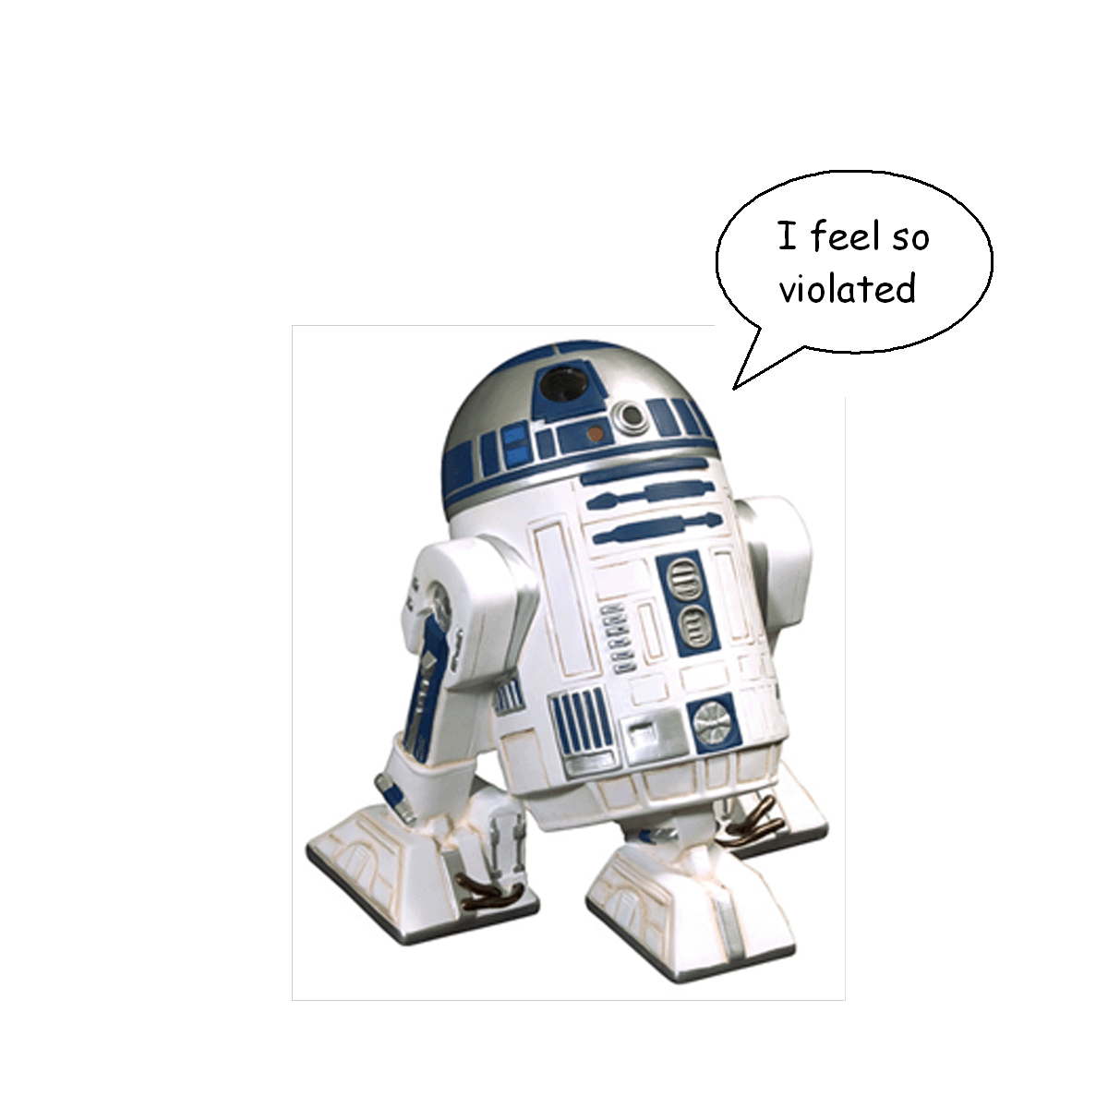

1. Alignment
2. Line Spacing
3. Numbering

DIRECTIONS:

1. Open a Word Document. Type your name. Hit ENTER

once. Type Activity 6. Hit ENTER twice.

1. Change to any BASIC font (no cursive), size 14 point.
2. Type the following title and paragraphs as written (use word wrap).

Amelia Island

While a remote tropical isle may be the ultimate winter escape, you need only head to the northeasternmost tip of Florida for an unspoiled, unpretentious refuge. Framed by 40-foot dunes, Amelia Island’s white sand beaches are remarkably uncrowded in mid-winter, in contrast to their more southerly counterparts.

You’ll also find plenty of fishing – on the island and offshore – bird watching, and horseback riding, and about 120 holes of that famous Sunshine State golf. At sunset, make your way to the downtown docks for the shrimp fleet’s return to Fernandina Harbor.

1. Hit ENTER twice. Type the following **list** of big words used in these paragraphs:

Remote

Unpretentious

Contrast

Counterparts

Southerly

5. Center the title Amelia Island and increase it to size 18 font. Hit ENTER again.

6. RIGHT Align the first paragraph. (You must highlight the paragraph first)

7. JUSTIFY the alignment in the second paragraph.

8. Highlight both paragraphs. Go to FORMAT – PARAGRAPH. Find LINE SPACING in the middle of the window and change from single space to 1.5 spacing. (If you need help with this part, let me know).

9. Go to the Home Tab – FONT. Change the font effects of each word in the list as follows: (Effects are found in the middle of the window. Effects are NOT the font style!)

Remote – Change to red font color

REMEMBER! You will have to highlight the word first!

Unpretentious – ~~Strikethrough~~

Contrast – Small Caps

Counterparts – Outline

Southerly – Underline with a dotted line

1. Highlight the whole list of words. Go to the Home Tab – BULLETS & NUMBERING. Click on Numbering and select a style of numbering for your list.
2. SAVE as Activity 6 on your H: Drive.